SIMATS ENGINEERING
ASSESSMENT TOOL 2
COURSE NAME: Ethical Hacking COURSE CODE: ITA14
________________________________________________________________________________________________________COURSE OUTCOME COVERED
CO2: Foot printing Tools: Conducting Competitive Intelligence, DNS Zone Transfers, Introduction to Social
Engineering: Social Engineering Attacks and Countermeasures. (BT4)

Assessment Tool Weightage: 30%

Duration: 90 min Total Marks: 50
______________________________________________________________________________________________________________________________________________________________________________

Social Engineering Simulation

Questions

- As a Security Analyst, perform an OSINT-based email enumeration assessment on the target domain tesla.com using theHarvester in Kali Linux. Collect publicly available email addresses, subdomains, hosts, and IP addresses associated with the organization. Categorize the discovered email addresses into likely roles such as Support, Sales, Human Resources, Administration, and Technical Teams. Analyse how the gathered information could assist an attacker during the reconnaissance phase and explain how it could be used for spear-phishing, credential harvesting, and impersonation attacks. Finally, recommend at least five countermeasures to reduce information leakage and social engineering risks, and submit a report with screenshots, commands executed, findings, risk analysis, and recommendations. (20 Marks)

Commands:
    - theHarvester -d tesla.com -b all
    - theHarvester –version

Purpose : This command performs an OSINT scan on the target domain tesla.com using the Rapid DNS search engine. It collects publicly available information such as email addresses, subdomains, hosts, and IP addresses.

Findings :

    - Emails: 0 (No public emails found)
    - Hosts/Subdomains: 668
    - IP Addresses: 53
    - Interesting URLs: 19
Risk Analysis

    - Public hosts and URLs reveal Tesla's external infrastructure.
    - Authentication portals may be targeted for credential harvesting.
    - Public service names can be used in spear-phishing campaigns.
    - Infrastructure details support reconnaissance and impersonation attacks.

Recommendations

  - Conduct regular OSINT assessments to identify exposed information.
  - Enable Multi-Factor Authentication (MFA).
  - Train employees to recognize phishing attacks.
  - Reduce unnecessary exposure of public subdomains.
  - Continuously monitor public-facing assets and DNS records.

Conclusion :
The OSINT assessment successfully identified public hosts/subdomains related to tesla.com. No public email addresses or IP addresses were discovered. The collected information demonstrates how attackers can gather infrastructure details during the reconnaissance phase and highlights the importance of minimizing public information exposure and implementing strong security controls.

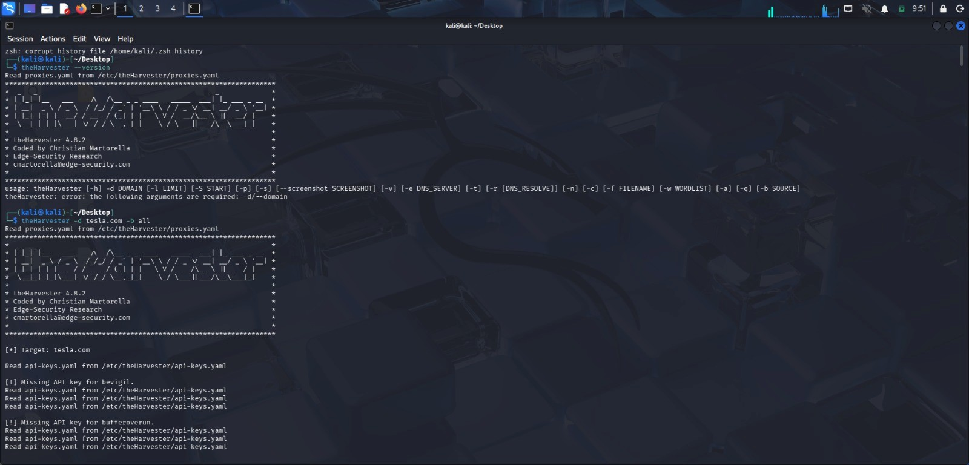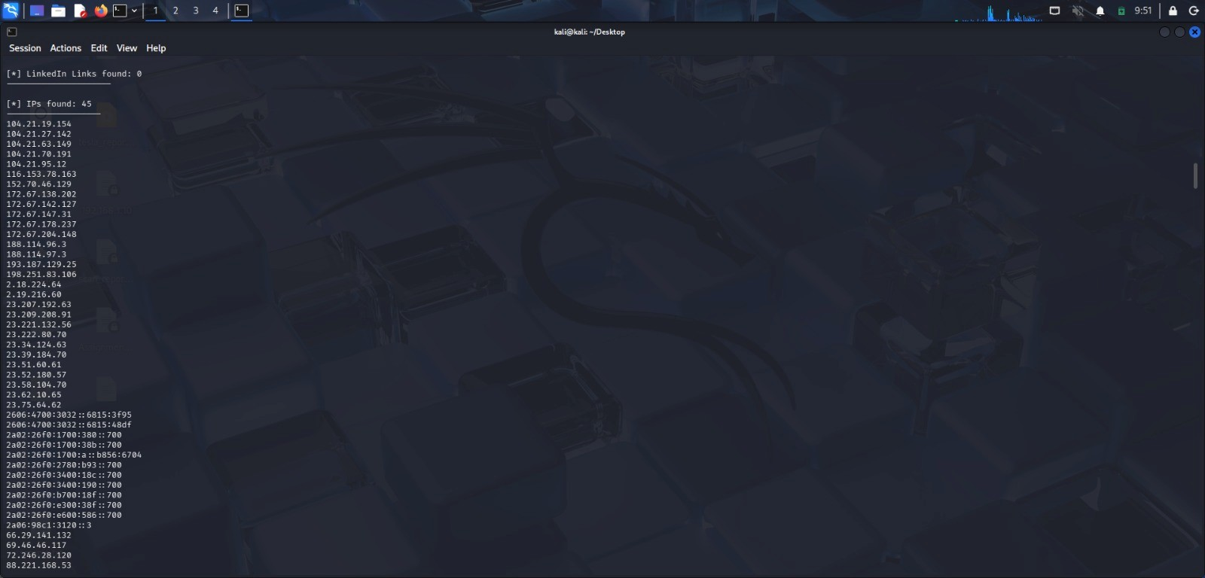
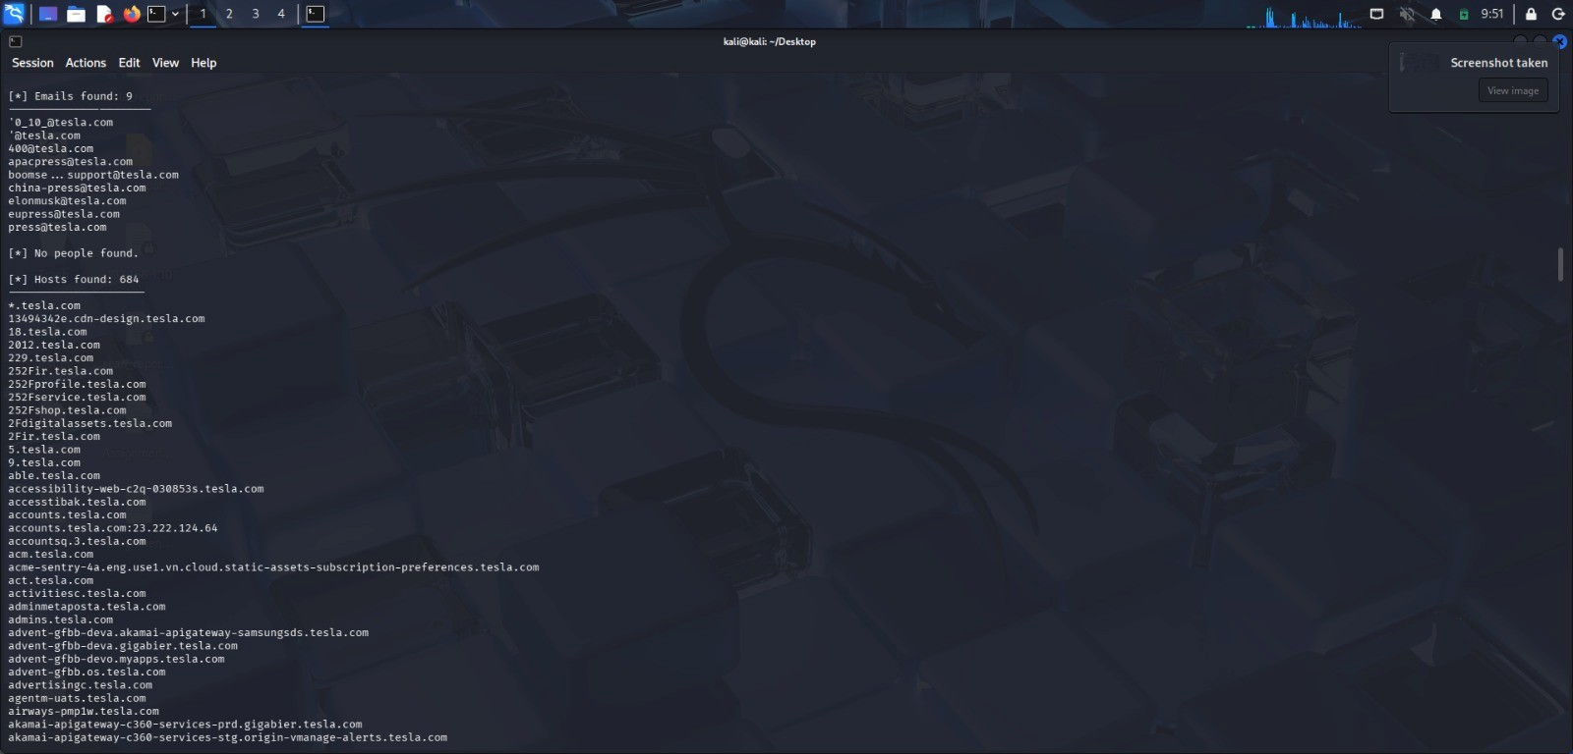
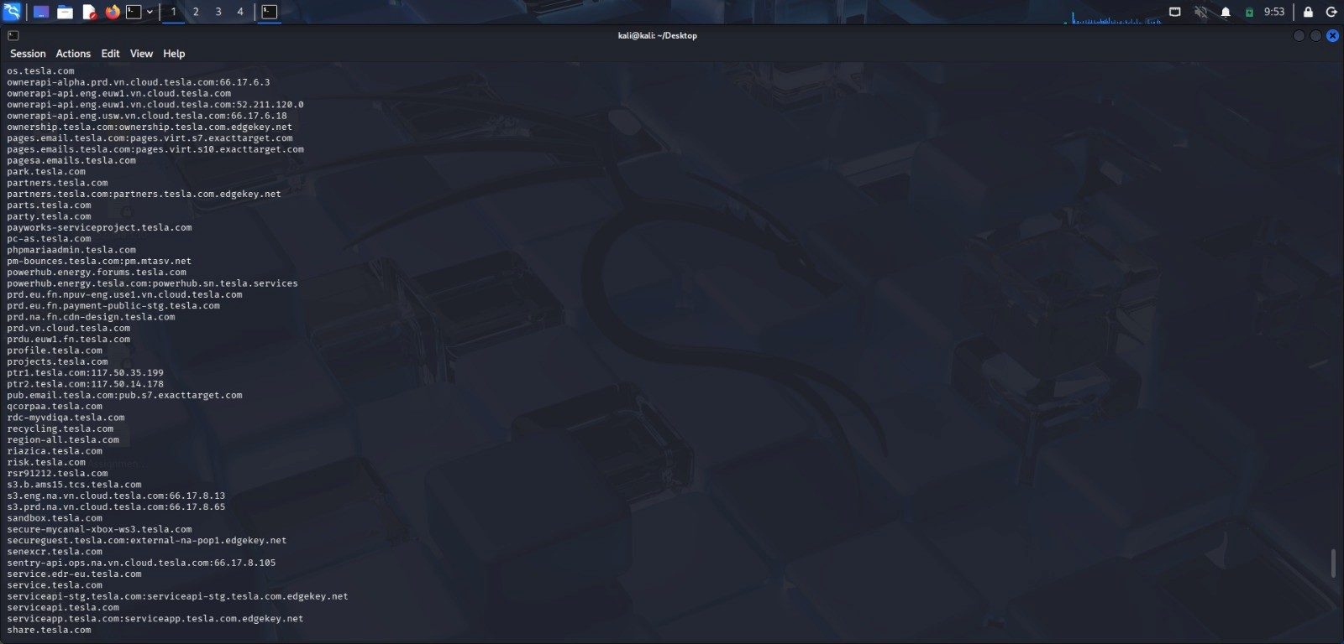
- As a cybersecurity awareness consultant, you are required to conduct a phishing awareness simulation using GoPhish and dummy employee accounts provided in the lab. Create an email template, launch a campaign, monitor user interactions, and generate a report showing delivery rate, email open rate, and click rate. Based on the results, provide recommendations to improve user awareness against phishing attacks.(20 Mark).

Metrics | Result
Target Users | 3
Email Sent | 1
Delivery rate | 33.3%
Procedure :

  - Created Email Template.
  - Created Landing Page.
  - Configured Mailtrap SMTP.
  - Created User Group.
  - Created Campaign.
  - Send phishing emails.
  - Viewed campaign statistics.

Email Security Controls :

  - Enable Spam Filtering.
  - Use Email Gateways.
  - Configure SPF (Sender Policy Framework).
  - Configure DKIM (DomainKeys Identified Mail).
  - Configure DMARC (Domain-based Message Authentication, Reporting, and Conformance).
  - Block dangerous attachments.
  - Scan email attachments using antivirus software.
  - Enable URL filtering.

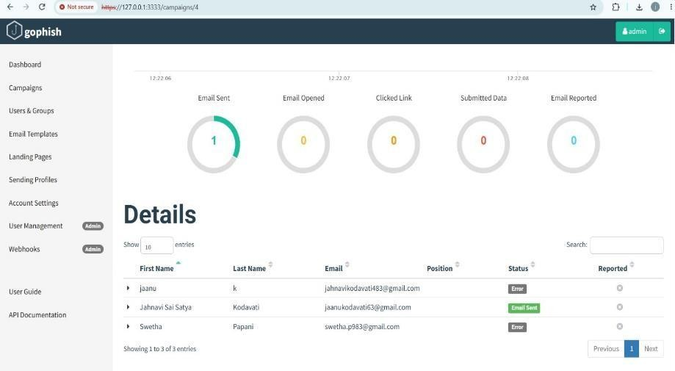
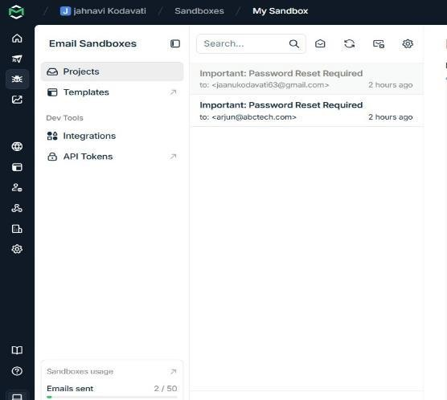

- Using Nmap Aggressive Scan (-A) on scanme.nmap.org, gather detailed information about the target including operating system details, open ports, and service versions. Assume you are an attacker and describe how the collected information could be leveraged to conduct a social engineering attack against the IT support team. Prepare a report explaining the attack methodology and defensive recommendations.(10 Marks)

Commands :
1. sudo nmap -A scanme.nmap.org Observation :
    - The host is alive.
    - HTTP (80) is open.
    - SSH (22) is open.
    - SIP ports 5060 and 5061 are open.
    - Operating system information identified.

Security Recommendations :

    - Keep all software updated.
    - Enable firewall protection.
    - Use strong authentication mechanisms.
    - Perform periodic vulnerability assessments.
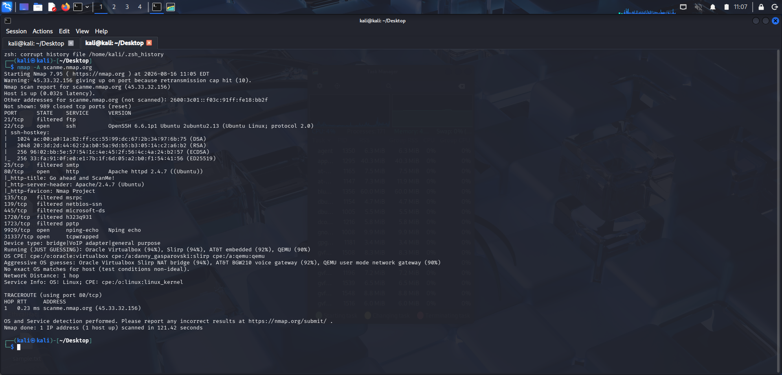

Code of Conduct:
I Hemalatha.C(192524475) (Name / Reg No) certify that this submission is my original work and that I have adhered to the guidelines specified for this assessment.
I understand that any violation of academic integrity rules will result in disciplinary action.
Signature of the student: Hemalatha.C

